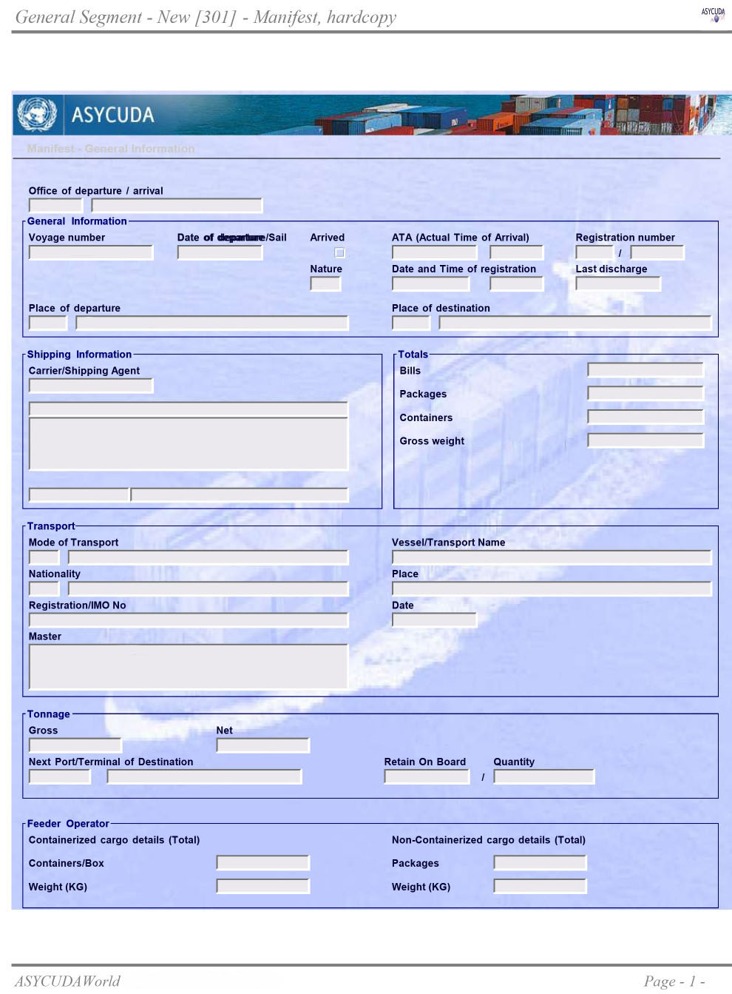
${companyaddress}
${last_portcode}
${msl_num}
301
23
0.00
0
${total_cargo_qty}
${total_bls}
${vsl_nrt}.00
${vsl_grt}.00
CAPT.${capt_name}
${vsl_imo}
${vsl_nationality}
${vsl_nationalitycode}
MV.${vessel}
Sea Transport
1
${total_cargo_qty}
0
${total_bls}.00
${total_bls}
${companyname}
${companyain}
Chittagong
BDCGP
${last_port}
${arrivaldate_forigm}
${deperture_date}
Custom House, Chattogram

